**Lab10 — AIG140 — Correspondence Analysis**

**Group 4**  
This lab is in two parts (A & B). The code for each part is appended at the end. For each of  
Part A and Part B, do the following:

1. Implement the code in Python.  
2. Insert screenshots of all visualizations in the relevant sections below.  
3. Answer the following questions, underneath the visualization for the relevant  
section below:  
a. Describe the dataset.

b. Explain the meaning of the result, by referencing the visualization.

c. Draw all the valid conclusions that you can from the visualizations, and  
justify them with an explanation.

**Part A**:

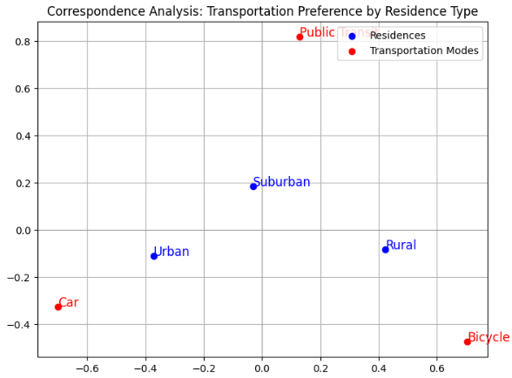Figure 1: Correspondence Analysis Plot for Product Preferences by Age Group

**Dataset Description:**

This dataset reflects how people choose their transportation methods according to their residential classification. The dataset organizes information into three residence areas including Urban, Suburban and Rural with three transport choices: Car, Public Transit as well as Bicycle. The table contains data about which transportation method each residential group from different areas chooses as their preference.

**Result Explanation:**

The correspondence analysis highlights the relationship between residence types and transportation preferences. Urban residents are associated with car usage, which indicates a strong preference for driving. Suburban areas are associated more with public transit, which indicates better access or reliance on such services. Rural residents are very close with the bicycle category, indicating a strong preference for cycling, which might be due to shorter travel distances or limited access to public transit. The separation of points in the biplot suggests clear differences in transportation preferences across residence types.

**Conclusions:**

The research data demonstrates that people from different living environments select different modes of transportation. The urban population has a preference for cars followed by suburban residents who choose public transportation while rural inhabitants select bicycles. People choose their transportation modes according to the characteristics of their residential areas which include physical infrastructure and neighborhood accessibility and way of life. Planned transportation solutions that target specific communities should consider residential behavior patterns to achieve better system optimization.

**Part B:**

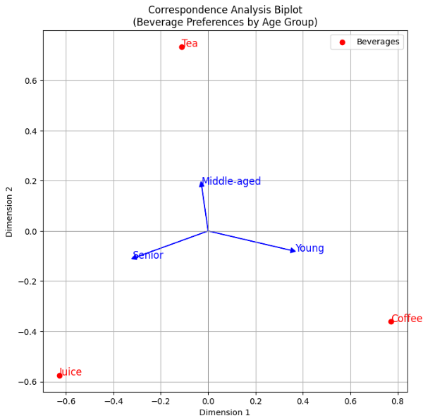

Figure 2: Correspondence Analysis Plot for Survey Responses by Region

**Describe the Dataset**

The dataset in Part B captures beverage preferences across different age groups. The 3x3 contingency table displays age groups Young, Middle-aged, and Senior across the rows while Beverage options Coffee, Tea, and Juice occupy the columns. A number of people within their respective age groups selected individual beverages and these values are represented in the table cells.

The multilevel organization of the data reveals how people make their beverage decisions based on age demographics. Young people tend to like coffee more than tea and juice but senior groups show greater preference for tea or juice than young generations. The categorical data structure enables correspondence analysis to display the strength of age group relations connecting them with their selected beverage preferences.

**Result Explanation:**

The display of correspondence analysis demonstrates how age groups connect to their preferred drink choices. Each age category has its preferred beverage shown by vectors through the diagram where "Young" group faces "Coffee" and "Middle-aged" group faces "Tea" while "Senior" group faces "Juice". The points representing different beverages separate distinctly from one another while their direction defines the preferences of each age group. The visual representation creates a clear understanding of dominant beverage choices among different age groups because they remain distinct with little points of intersection which provides important knowledge useful for specific marketing strategies.

**Conclusions:**

The evaluation demonstrates that beverage choices differ substantially between different age segments. People in their early lifecycle choose coffee while those in their middle age prefer tea along with seniors who overwhelmingly select juice as their beverage of choice. These different choice patterns demonstrate how aging affects consumer decisions thus providing effective opportunities for targeted advertising of specific products to certain consumer groups.